STUDY OF THE INFLUENCE OF HYPOKINESIA ON THE STRUCTURE AND FUNCTIONAL STATUS OF THE LIVER OF RATS
¹ Srailova G.T., ² Babashev A.M., ³Sagindikova E. U., ¹Yessimsiitova Z.B.
⁴ Kidirbaeva Kh.K., ³Bisenova L. E., ³Muratbekova N. Zh., ³Yekibaeva G.N.
¹al-Farabi Kazakh National University, Almaty, Kazakhstan
²Abai name Kazakh National Pedagogical University
³ Yessenov University, Kazakhstan
⁴ South Kazakhstan State University named after M. Auezov
Abstract :
Hypokinesia is a condition of the body in which there is insufficient motor activity, causing a limitation of the pace and range of motion. The restriction of motor activity is accompanied by deep metabolic disturbances in the body, which reduces adaptive capabilities, distorting the body's responses to numerous extreme factors. Under the motor activity is usually understood as muscle loads, and their limitation - hypokinesia. The basis of the work is the results of histological studies of rat liver cell populations that received hypokinesia and hypokinesia using a biologically active additive of the specialized Mildir detoxifying product. As a result of the study, it is clear that the specialized product has directed physiological and biochemical properties, increases the adaptive capabilities of the body in conditions of reduced physical activity. The use of a specialized product increases stability and reduces the period of adaptive and readaptation disorders in the body.
Keywords: liver, specialized products, necrosis, morphology, hypokinesia, destruction, nutrition.

Relevance :
The restriction of motor activity is accompanied by deep metabolic disturbances in the body [1-7], which reduces adaptive capabilities, distorting the body's responses to numerous extreme factors. Hypokinesia is a complex of disorders, including a decrease in motor activity and slow movement. Pathology usually develops with lesions of the central nervous, digestive, respiratory, digestive systems. The effect of hypokinesia on the body reduces adaptive and compensatory reactions, the functional and structural basis of movement changes, a pathological decrease in motor activity with impaired energy and metabolism is observed, and oxygen deficiency increases.
Currently, the study of the body's adaptation to the action of environmental factors, to physical activity, is one of the main problems in the field of biology and medicine. It is known that the complex effect of extreme environmental factors on the human body can lead to certain changes in physiological and metabolic processes, which to a large extent leads to increased energy consumption, increased demand for certain nutritional factors [8-12].
Nutrition is the most important environmental factor on which the human health and well-being decisively depends, and is also the most important physiological need of the body. Metabolism, function and structure of all cells, tissues and organs are dependent on the nature of nutrition. The nature of the diet can affect the degree of negative effects on the body of potentially hazardous chemicals and adverse environmental factors.
The concept of rational nutrition in most countries in the most generalized form is reflected in officially recommended nutritional standards that characterize the needs of various groups of the population in energy and basic nutrients. In recent years, due to the high workload at work and at home and other reasons, the majority have a deficiency in the daily regimen, insufficient motor activity, which leads to the appearance of hypokinesia, which can cause a number of serious changes in the human body. A sedentary position affects the functioning of many body systems, especially the cardiovascular, digestive and respiratory systems. With prolonged sitting, breathing becomes less deep, the metabolism decreases, blood stagnates in the lower extremities, which leads to a decrease in the efficiency of the whole organism and especially the brain: attention is reduced, memory is weakened, coordination of movements is impaired, and the time of mental operations increases. Motional activity usually refers to both muscle loads and their limitation - hypokinesia [13-19]. In conditions of complete immobility, it turned out that motor hunger leads to significant changes in the body. First of all, energy metabolism is disrupted, that is, the process of oxidation of carbohydrates, fats and proteins. Due to the weakening of the processing of fats, primarily of animal origin, in the blood, the content of cholesterol and a number of other compounds increases, which inevitably accelerates the development of atherosclerosis of the vessels of the brain, heart, liver and other organs. It should be emphasized that hypokinesia disrupts all types of metabolism [20-27]. Hypokinesia causes a decrease in the body's resistance to various diseases, including infectious ones. Chronic diseases are exacerbated. Such an extensive list of various diseases caused by an imbalance in the energy biochemical metabolism that the body inflicts indicates the use of biologically active additives (BAA) [28-33]. Most leading doctors and scientists around the world are convinced that dietary supplements are an ideal, safe and reliable way to improve health, maintain longevity and facilitate the treatment of diseases. Biologically active food supplements are a unique group of products that are intended for use by both healthy and sick people.
One of the most important disorders at this stage should be considered a decrease in the antioxidant defense of the body, leading to violations of its functional activity at the cellular level. For the correction of these changes, the intake of dietary supplements is vital. It is advisable to use dietary supplements containing vitamins, trace elements, polyunsaturated fatty acids, proteins and amino acids, dietary fiber, adaptogens, antioxidants, immunostimulants, eubiotics, general strengthening agents and agents that help cleanse the body. Hypokinesia has become one of the pressing problems of our time, requiring the adoption of urgent measures to prevent it. In this regard, the study of the mechanisms of hypokinetic disorders, the development of methods for the prevention and correction of the effects of hypokinesia acquire great social significance. That is why recently interest in the problem of hypokinesia has especially increased in such developed countries as the USA, Japan, Germany, France, Canada.
From the literature data it is known that morphofunctional changes in the organs of animals and humans during hypokinesia using dietary supplements are not well understood. In this regard, the goal of our work was a fundamentally new approach in the development of diets, specialized products and the study of their action at a morphological level. All of the above determines the relevance of studying and using specialized products for hypokinesia, the pathogenesis of which is based on a whole series of information about metabolic disorders, structural and metabolic statuses of the body.

Materials and methods :
An experimental study was conducted on 30 experimental sexually mature rats - Wistar males, three months old with an initial body weight of 180-220 grams to identify the adaptive capabilities of rats that received hypokinesia using biologically active additives: the specialized detoxifying product Moldir. During the experiment, all animals were, in the same standard, vivarium conditions (Fig. 1). The decapitation of animals was carried out using anesthesia at a strictly fixed time - between 9 and 11 in the morning. The object of histological examination was the main population of liver cells. The whole experiment was carried out for 30 days, all animals were divided into 3 groups: 1 group of animals - control; Group 2 animals were kept under hypokinesia for 30 days; The 3rd group of animals was kept under conditions of hypokinesia and received a detoxifying specialized product “Mouldir” for 30 days. A balanced diet (basic diet) included the following components: wheat bran - 36.6 (%); wheat flour of the first grade - 25.0 (%); starch - 12.1 (%); casein - 11.5 (%); lard - 6.4 (%); sucrose - 3.0 (%); linetol - 2.0 (%); salt mixture - 3.2 (%); vitamin mixture - 0.2 (%). On the background of hypokinesia, the animals received a detoxifying specialized product “Muldir” based on dry powders of fruits and berries with the addition of dried mare's milk, as well as a complex of vitamins: A, E, C, folic acid, iron, zinc, magnesium and selenium. These products, depending on the ratio of ingredients to a greater extent, showed either antioxidant, antitoxic, or immunocorrective properties.

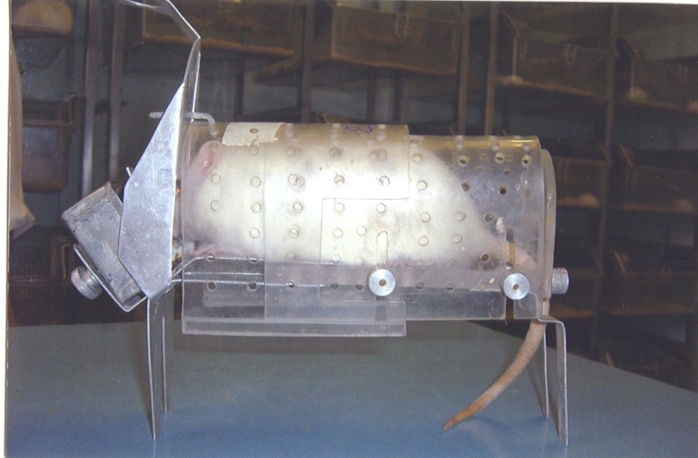
Figure 1. Cell - pencil case for modeling hypokinesia
Table 1 - Recipes for special products based on 100g of product
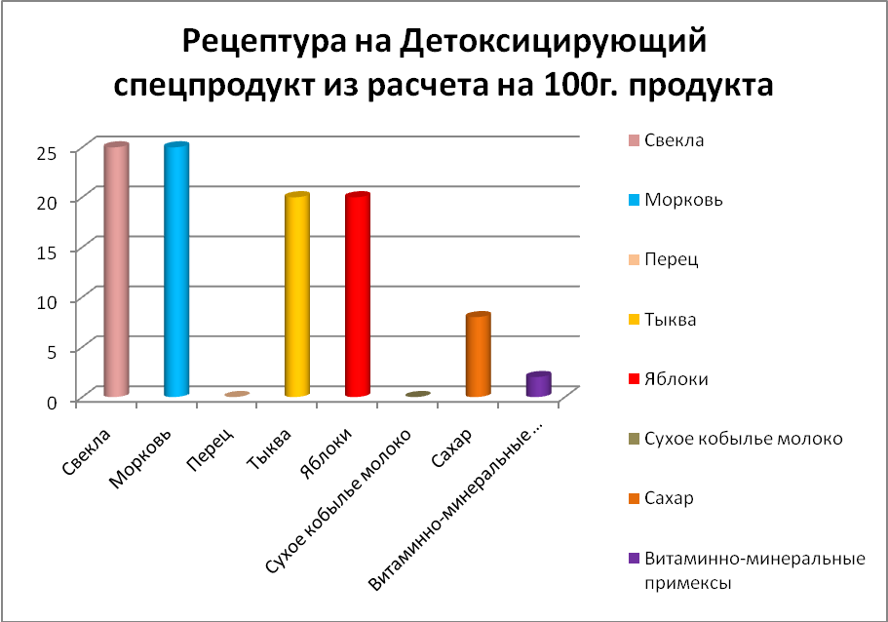
As a result of the experiment, the following components of specialized products were used: beets, carrots, peppers, pumpkins, apples, dried mare's milk, sugar, vitamin and mineral complex.
Organoleptic characteristics of specialized products are presented in table 2, physico-chemical indicators in table 3.

Table 2 - Organoleptic characteristics of specialized products
Name |  | Vegetable Powder Based | Fruit Powder Based | Based on a mixture of fruit and vegetable powders
Appearance and shape | powder | Homogeneous powdery mass
 | granules | Round or oval
 | color | Inherent to the raw materials used
 | taste and smell | Inherent to the raw materials used, without extraneous taste and odor

Table 3 - Physico-chemical characteristics of specialized products
Name of indicator | Detoxifying product
Moisture, % | 7,7
Ash, % | 10
Vitamin С, мг% | 100
Foreign matter, % | Snooze.
Metallomagnetic impurities, % | Snooze.

Semi-synthetic diet and water experimental animals received ad libidum. The control was a group of animals located throughout the experimental period on a semi-synthetic diet and receiving a 2% glucose solution. For histological examination, generally accepted methods for preparing sections were used. 40 paraffin blocks and 120 histological preparations were made. The obtained histological preparations were studied using a MicroOptix MX300T optical microscope with a digital camera. Microphotography of the obtained preparations was carried out at an increase of x100, x200, x400.
To determine the hematological parameters of blood (the amount of hemoglobin, erythrocytes, platelets and leukocytes, as well as ESR and blood coagulation rate), we used the Abacus Junior Vet automatic hematology analyzer, manufactured by DIATRON (Austria). The analysis of biochemical parameters was carried out on a Dimension Xpand Siemens automatic biochemical analyzer (Germany). Blood sampling in laboratory animals was carried out by decapitation method.
During the experiment, the state of the animals was monitored daily. During external examination of experimental animals of the second group, significant physiological differences from rats of the control group were noted. The coat was heterogeneous, ruffled, the pupils were enlarged with a reddish tinge, lethargy of animals, isolated spasms, and partial aggressiveness were noted.
Results and discussion. A histological study of semi-thin sections of control rats shows that the liver consists of hepatic lobules and beams. Lobules are separated from each other by layers of loose connective tissue. Between sinusoids are located radial cords of hepatic cells - hepatocytes. They are multifaceted in shape, with 1-2 or more rounded nuclei. The surface of the hepatocytes, facing the sinusoid, has microvilli. The cytoplasm is pink, the nucleus is rounded with a clear border, the nucleolus is well defined. In the center at the place of contact of the cells pass the bile capillaries. The bile canaliculi at the periphery of the lobules are covered with a single-layer cubic epithelium, forming an interlobular bile duct (Fig. 2). No physiological changes were observed. General condition is satisfactory. A histological study of control rats that did not undergo hypokinesia and did not receive a specialized product showed that all organs are normal, the structure is preserved. No special pathological and physiological changes were found.
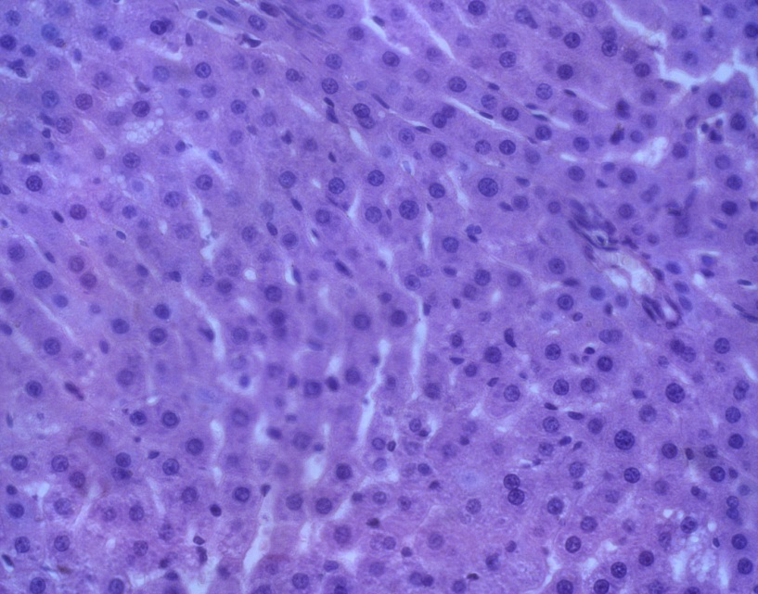

Figure 2. The histological structure of the rat liver is normal.
Semi-thin section. Hematoxylin-eosin stain. UV.x 400. As a result of a morphological study in animals that received hypokinesia for a month, showed that pathological changes are visible in the liver cells. Reducing muscle effort, when the movements are carried out, but with extremely small loads on the muscle apparatus, skeletal muscles are completely underloaded. There is a huge deficit in the biological need for movement, which dramatically reduces the functional state and performance of the body. The content of rats for one month under hypokinesia survival rate of 80%. There was no death. There were metabolic and physiological disturbances. Liver sinusoids were enlarged due to edema. In some places, areas of fuzzy borders, dystrophy, destruction, and blurring of cells are observed (Fig. 3). Hepatocytes with fuzzy vacuolated cytoplasm, nuclei blurry. Individual hepatocytes in a state of hydrolytic dystrophy. At times, rat nervousness, aggressiveness were found, and the mass of the organs studied did not change in calmly surviving hypokinesia rats, but decreased in restless ones. Consequently, the histological examination of the organs of the animal liver, which underwent hypokinesia for a month, pathological changes in the microstructure of the organs studied are pronounced.
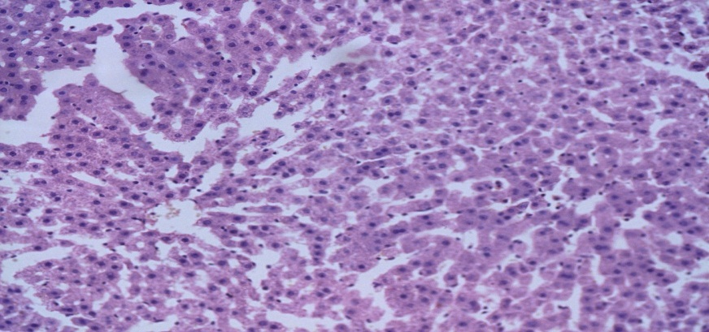
Figure 3. Liver edema. Semi-thin section.
Hematoxylin-eosin stain. UV.x 200. During histological examination of the liver of organs of experimental animals of the third group, which underwent hypokinesia and received a detoxifying specialized product “Muldir”, the organ structure was preserved, no special destructive changes were found. The specialized detoxifying product "Muldir" was taken for a longer time, its action is mild, without adverse destructive reactions. It was found that the use of dietary supplements made it possible to consistently and purposefully restore the body without causing damage to it.
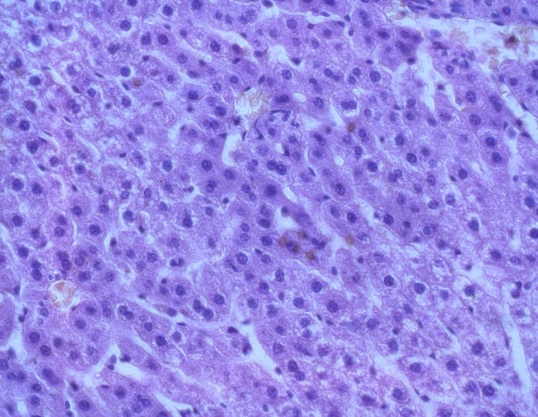
Figure 4. Partial dystrophy of hepatocytes. Semi-thin section.
Hematoxylin-eosin stain. UV.x 400. When using dietary supplements, the physiological and pathological process is affected by substances related to the body and physiologically necessary for it, substances to which the body adapted in the process of evolution, and which came into it with food. In this case, dietary supplements do not cause protective reactions. When using dietary supplements as a means of adjuvant therapy, a decrease in pathomorphological processes is seen, a slight interstitial edema is observed, but the beam structure is unchanged, the nuclei are outlined. Partial pronounced plethora of the central veins, vessels of the portal tracts (Fig. 4). Hepatocytes with eosinophilic cytoplasm and basophilic nucleus.
The use of dietary supplements is aimed at strengthening the body, increasing its adaptive mechanisms and the rehabilitation of chronic conditions. Prevention with the use of the specialized detoxifying product “Moldir” is the most acceptable, as it has non-toxicity and effectiveness in applying long-term targeted preventive and restorative effects on the body. Histological examination of the liver of rats of the third group, which received hypokinesia and a detoxifying specialized product “Muldir” for a month, shows that the structure of the organ is preserved, a partial change is observed. Individual hepatocytes in a state of hydrolytic dystrophy, the nucleus is not clearly contoured. Mild plethora of the central veins, vessels of the portal tracts.
The blood system has long been a reliable clinical indicator for assessing the state of the body; it plays the role of an effector in the implementation of adaptive trophic changes in metabolism. Red blood cells are normally in isotonic saline and are more susceptible to shock than other cells. Violation of the functional integrity of the membrane leads to the loss of a biconcave shape and, ultimately, hemolysis. Identification of functional morphological and biochemical changes during hypokinesia is essential in theoretical and practical aspects. When studying hematological parameters under conditions of hypokinesia, the ability of secretory products of hematogenous origin to regulate the activity of neuroendocrine stress mechanisms is not taken into account. Moreover, in accordance with the generally accepted point of view, the nervous system plays a leading role in the perception of stress signals from the environment, and the endocrine system programs the stress response in response to various disorders of homeostasis. In rats under hypokinesia, there is an increase in serum enzyme indices: alkaline phosphatase by 3.06 times, AsAT by 1.86 times, AlAT by 1.87 times and is 3.10 ± 0.05 mmol / l, 1 86 ± 0.08 mmol / L; 1.08 ± 0.07 mmol / L, respectively (P <0.001). The cause or effect of various pathological conditions is a violation of the normal functioning of enzyme processes. The data obtained in the experimental groups of animals that received a dietary supplement with a diet showed a decrease in enzyme indices, indicating weak pathological changes in the body. After detoxification, hematological blood counts have improved markedly.
Conclusion. All of the above determined the purpose of this study, aimed at solving problems of developing specialized products that increase the stability of the body. It was found that specialized products possess directed physiological and biochemical properties, increase the adaptive capacity of the body in conditions of reduced motor activity, as well as the effects of hypokinesia on the body of experimental animals. In addition, the use of specialized products will increase the body's stability and reduce the period of adaptive and readaptation disorders in the body. The data obtained can justify the use of dietary supplements for therapeutic purposes, as a factor that increases the adaptive capacity of the body. An experimental study of 30 experimental sexually mature rats - Wistar males, three months old with an initial body weight of 180-220 grams revealed morphological changes in the liver organs that occurred under the influence of hypokinesia and hypokinesia with the addition of a specialized supplement. No significant changes were observed in control rats. Weaknesses, malaise, and behavioral changes were not found in rats, the general condition is normal, the total weight, the pupils and the coat are normal, and no physiological abnormalities were observed. In animals of the second group, more than half of the experimental animals are relatively calmly under conditions of hypokinesia, the rest show agitation and even some aggressiveness, which is obviously associated with hypokinetic stress. The mass of the studied organs in rats calmly undergoing hypokinesia was unchanged, while in restless rats it decreased. Morphofunctional changes depend both on the duration of hypokinesia and on the manifestation of hypokinetic stress. In the liver of animals after 30-day hypokinesia, cell dystrophy, blur, violation of compensatory-adaptive reactions were detected. Around the microvessels, pericapillary edema is formed. Often thinning and swelling of the wall are detected in the same capillary. In animals of the third group, when studying the organs of the liver, a partial change in the organs was observed, the beam structure was preserved, hepatocytes with fuzzy vacuolated cytoplasm, and the nuclei were blurred.
Hematological studies have shown that the selection of adequate conditions for creating the same depth of stress in the presentation of various stimuli is difficult due to the specificity of the action of each of them. It is advisable to expand the range of hematological markers of stress. Blood, as a more or less homogeneous tissue with a pronounced morphological and biochemical manifestation of cell specialization and the ability to repeatedly obtain samples for analysis, can serve to study the processes of adaptation, resistance, and maintaining the constancy of the internal environment of the body.
Given that in modern life the reserve capabilities of the human body are under pressure from an unfavorable environmental situation, psychoemotional and physical stresses, changes in lifestyle and nutrition. As a result of this, at this stage, to maintain health, it is advisable to use dietary supplements containing vitamins, trace elements, dietary fiber, antioxidants, adaptogens, as well as promoting the removal of metabolic products and other harmful substances from the body. Studies have shown that rat hypokinesia leads to compensatory-destructive changes, followed by dystrophy and cell response. The use of the specialized detoxifying product Muldir helped to reduce circulatory disorders and dystrophic processes.

List of references :

- The nutritional value of canned products in tubes for feeding pilots and astronauts / L.I. Kuznetsova [et al.] // Cosmic. biol. and aerospace. honey. - 1983. - No. 2. - S. 30–35.
- Kovalenko, EA Hypokinesia / E.A. Kovalenko, N.I. Gurovsky. - M.: Medicine, 1980 .-- 320 p.
- Change in the state of bone tissue in women under conditions of 120-day anti-orthostatic hypokinesia / V.S. Oganov [et al.] // Aviation, and ecologist, honey. - 1997. - T. 31, No. 5. - S. 59–63.
- Vainbaum Ya.S. Dosing of physical activity of schoolchildren. - M.: Education, 1991, 64 p.
- Solodkov A.S., Sologub E.G. Human physiology is general, sports, age. - M.: Tera-Sport, 2001, 520 p.
- Fomin N.A., Vavilov Yu.N. Physiological basis of motor activity. - M.: Physical Education and Sports, 1991, 224 p.
- Menhin Yu.V. Physical training in gymnastics. - M.: Physical Education and Sports, 1989 .-- 224 p.
- Yessimsiitova, Z., Ablaikhanova, N., Sagyndykova, S. and ect. Increase of Healthy Food Quality among the Kazakhstan Population., Journal of Pharmacy and Nutrition Sciences, Volume 8, Issue 3, 2018, Pages 150-153
- Skurikhin I. A /., Nechaev A. P. Everything about food from the point of view of a chemist. - M .: Higher school. 1991.-286s.
- Oreshchenko A. V. Beresten A. F. About food additives and food products // Food industry. - 1996. - No. 6. - S. 4.
- Yessimsiitova, Z.B.a, Ablaikhanova, N., and ect. Efficacy of application of dietary supplements in acute intoxication. Journal of Pharmacy and Nutrition Sciences, Volume 9, Issue 4, 2019, Pages 229-232
- Fomin N.A., Vavilov Yu.N. Physiological basis of motor activity. - M.: Physical Education and Sports, 1991, 224 p.
- Tigranyan R.A. (1985). In Sat: Metabolic aspects of the problem of stress in space flight. - M., 52, 11-23.
- Yeshenko N.D. (1982) In the book: Methods of biochemical research. L., 29-32.
- Meerson F.Z. (1984) In the book: Pathogenesis and prevention of stress and ischemic damage to the heart. M.,. 102-108.
- Kovalenko E.A., Gurovsky N.N. Hypokinesia.- M .: Medicine, 1980.- 237 p.
- Mikhailov A. Z. Functional morphology of rat neutrophils in the process of adaptation to hypokinesia: Author's abstract. dis. ... cand. honey. sciences. Simferopol, 1986.- 24 s.
- Evstafyeva E. R. Change in lipid metabolism and blood system in rats upon adaptation to hypokinesia // Abstract. diss. ... Candidate of Biological Science. - L., 1985 .-- 24 p.
- Mogendovich, M.R. Hypokinesia as a factor in the pathology of internal organs / M.R. Mogendovich // Physiology and pathology of motor-visceral reflexes. - Perm, 1961. - Issue. 3. - S. 9–26.
- Grigoriev, A.I. Hypokinesia: medical and social aspects / A.I. Grigoryev. - M. - 1997. - S. 28–29.
- Shustov, E.B. Patterns of adaptation to activities in extreme conditions / E.B. Shustov, V.S. Novikov, V.V. Goranchuk // All-Russian Scientific Conference with international participation, dedicated to the 150th anniversary of the birth of Academician Ivan Petrovich Pavlov, St. Petersburg, September 15-17, 1999 .: Conference proceedings. - 1999 .-- S. 53-56.
- Vasiliev, V.P. The effect of prolonged hypokinesia on the course of some pathological processes / V.P. Vasiliev, V.E. Belay, G.D. Glad // In the book: Aerospace medicine: Abstracts. Doc. V All-Union. conf. - M., 1995 .-- T.2. - S.125–126.
- Shurygin, D.Ya. Endocrine systems in case of physical inactivity and readaptation / D.Ya. Shurygin, K.A. Sidorov, V.I. Mazurov // Military Medic. Journal. - 1976. - No. 12. - S. 55–58.
- Tigranyan, R.A. The state of metabolic processes in conditions of limitation of motor activity / R.A. Tigranyan, M.I. Belyakova, M.A. Davydova // In the book: Aerospace honey .: Thesis. doc. All-Union. conf. - M, 1975 .-- T.2. - S.187-190.
- Rylnikov, Yu.P. The effect of hypokinesia on the lipid composition of blood and tissues in rabbits of various ages / Yu.P. Rylnikov // Cosmic. biol. and aerospace. honey. - 1974. - T.8, No. 2. - S.8-14.
- Kovalenko, E.A. About the problem of hypokinesia in modern medicine / E.A. Kovalenko // Hypokinesia. Medical and psychological problems. - M., 1997. - S. 35–36.
- Mikhailov, V.M. Hypokinesia as a risk factor in extreme conditions / V.M. Mikhailov // Aviation. and ecol. honey. - 2007. - No. 2. - S. 26–31.
- The possibilities of using specialized products and biologically active additives in increasing the adaptive capacity of the body when exposed to adverse factors of space flight / A.N. Agureev [et al.] // International scientific conference “Sovereign Kazakhstan: 15-year-long development path of space activity”, dedicated to the 70th anniversary of academician U.M. Sultangazina. Almaty.- 2006.- S. 291-292.
- Kovalenko, E.A. Pathophysiological aspects of the problem of prolonged hypokinesia / E.A. Kovalenko // Pathological. physiology and experimental therapy.- 1975.- No. 3.- P.11-18.
- Yu. Yu. Gichev, Yu. P. Gichev “A Guide to Micronutrientology. The role and importance of biologically active food additives ", M .:" Triad-X ", 2006.
- Dobrovolsky V.F. Nutrition of astronauts / V.F. Dobrovolsky. - Moscow, 2006. - 143 s.
- Ramakrishnan, J., Shabbir, M. S., Kassim, N. M., Nguyen, P. T., & Mavaluru, D. (2020). A comprehensive and systematic review of the network virtualization techniques in the IoT. International Journal of Communication Systems, 33(7). https://doi.org/10.1002/dac.4331
- Shabbir, M. S., Siddiqi, A. F., Yapanto, L. M., Tonkov, E. E., Poltarykhin, A. L., Pilyugina, A. V., Petrov, A. M., Foroughi, A., & Valiullina, D. A. (2021). Closed-loop supply chain design and pricing in competitive conditions by considering the variable value of return products using the whale optimization algorithm. Sustainability, 13(12), 6663. https://doi.org/10.3390/su13126663
- Shabbir, M. S., Mahmood, A., Setiawan, R., Nasirin, C., Rusdiyanto, R., Gazali, G., Arshad, M. A., Khan, S., & Batool, F. (2021). Closed-loop supply chain network design with sustainability and resiliency criteria. Environmental Science and Pollution Research. https://doi.org/10.1007/s11356-021-12980-0
- Shabbir, M. S., Abbas, M., & Tahir, M. S. (2020). HPWS and knowledge sharing behavior: The role of psychological empowerment and organizational identification in public sector banks. Journal of Public Affairs. https://doi.org/10.1002/pa.2512
- Shabbir, M. S., Bait Ali Sulaiman, M. A., Hasan Al-Kumaim, N., Mahmood, A., & Abbas, M. (2020). Green Marketing Approaches and Their Impact on Consumer Behavior towards the Environment-A Study from the UAE. Sustainability, 12(21), 8977. https://doi.org/10.3390/su12218977
- Siddiqi, A. F., Shabbir, M. S., Abbas, M., Mahmood, A., & Salman, R. (2021). Developing and testing student engagement scale for higher educational students. Journal of Applied Research in Higher Education, ahead-of-print (ahead-of-print). https://doi.org/10.1108/jarhe-11-2020-0388
- Rabin, B.M. Effects of age and diet on the heavy particle-induced disruptions of operant responding produced by a ground-based model for exposure to cosmic rays / B.M. Rabin, J.A. Joseph, Hale, B. Shukitt // Brain Research. - 1036 (2005). - P.122–129
- Sinyavsky, Yu.A. Therapeutic and prophylactic food products / Yu.A. Sinyavsky, I.G. Tsoi.- Almaty.- 2009.- 183 p.

